JAVA MINI

PROJECT

# PASSWORD GENERATOR



## INTRODUCTION

A Password Generator is a software utility that provides users with a system to create a unique and random password that can be used for securing their digital identity. This Java-based project is a

powerful tool that helps in generating highly secure passwords which are difficult to crack.The basic

concept of this application is to allow the user to generate a password virtually using java. We’re using different types of password generators to create different kinds of passwords for our everyday digital platforms. Such as:

* Manual Password Generation – This is a traditional method where users create passwords manually,often leading to weak passwords due to human tendencies.
* Automated Password Generation – This is a modern approach where a software utility, like ourJava-based Password Generator, creates a strong and unique password automatically, enhancing the security of the user’s digital identity.

# PROBLEM STATEMENT



Our product is a Java-based Password Generator that enables users to create secure and unique passwords. It operates

through a server program on the user’s home computer, with a

Java-based client connecting to the server to generate the password. The challenge it addresses is the difficulty and time-

consuming nature of manually creating strong, unique passwords for various digital platforms.

CODE

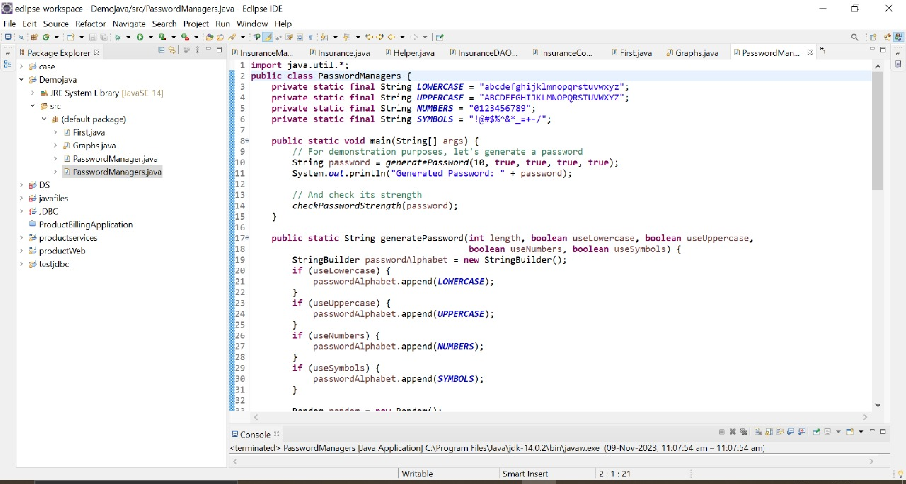

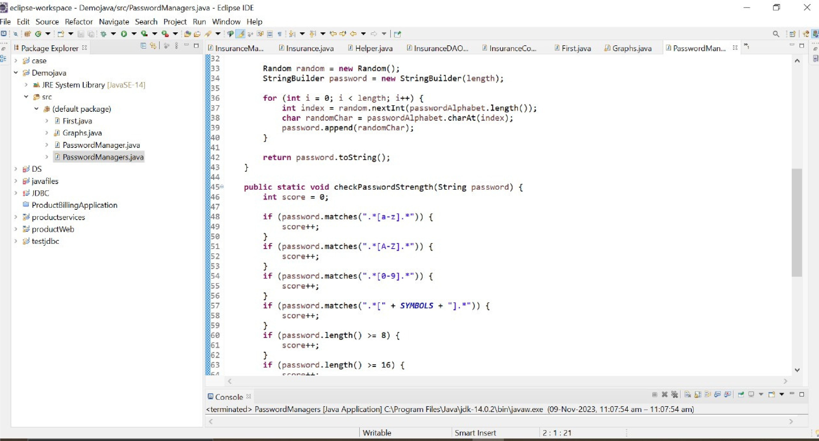

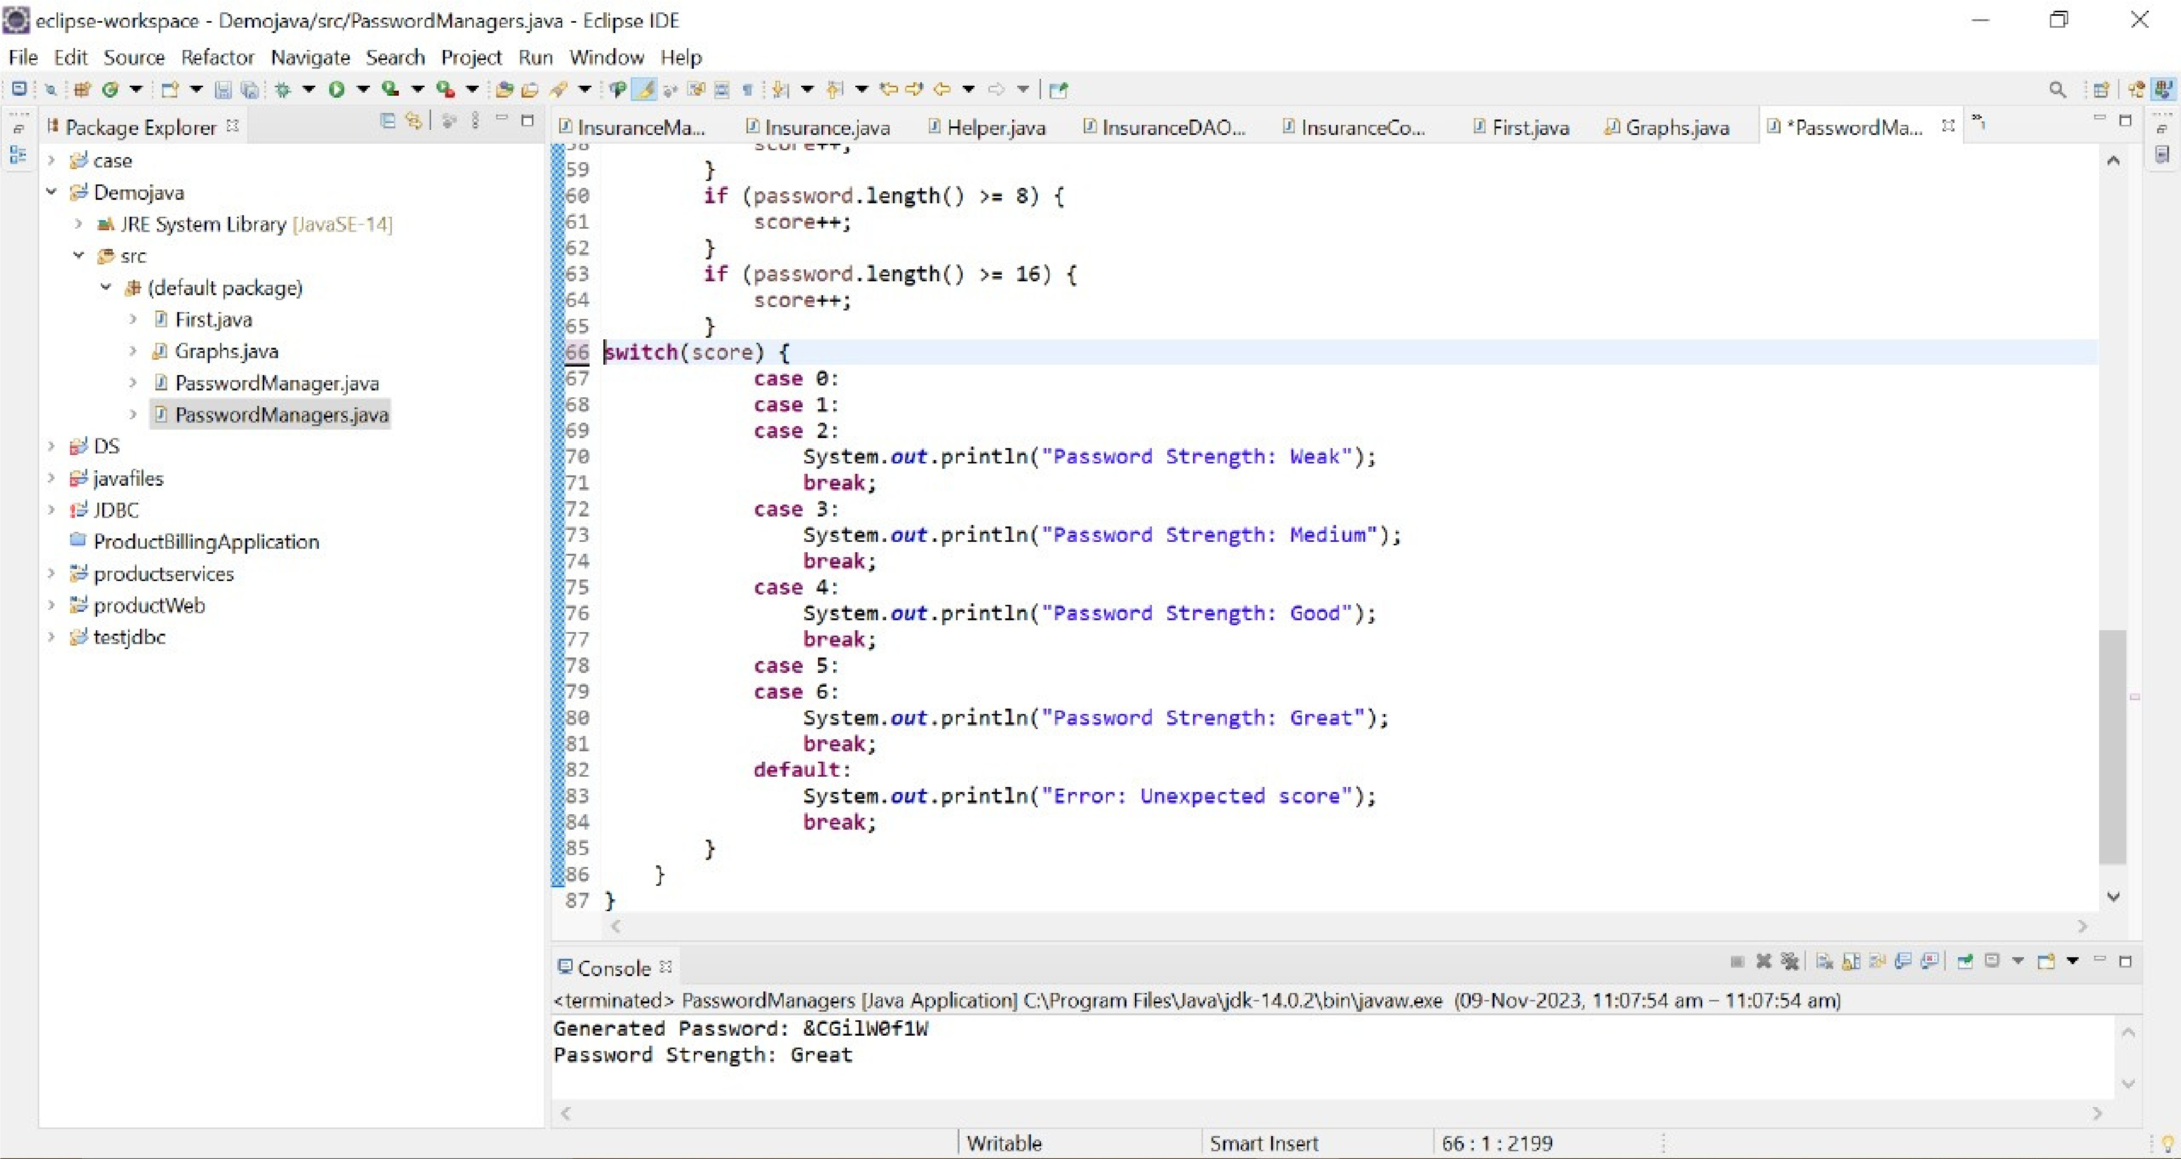

## OUTPUT

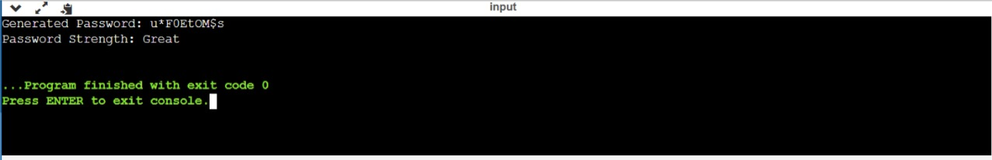

:

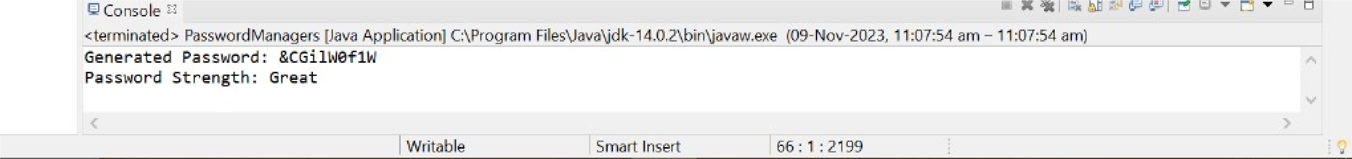

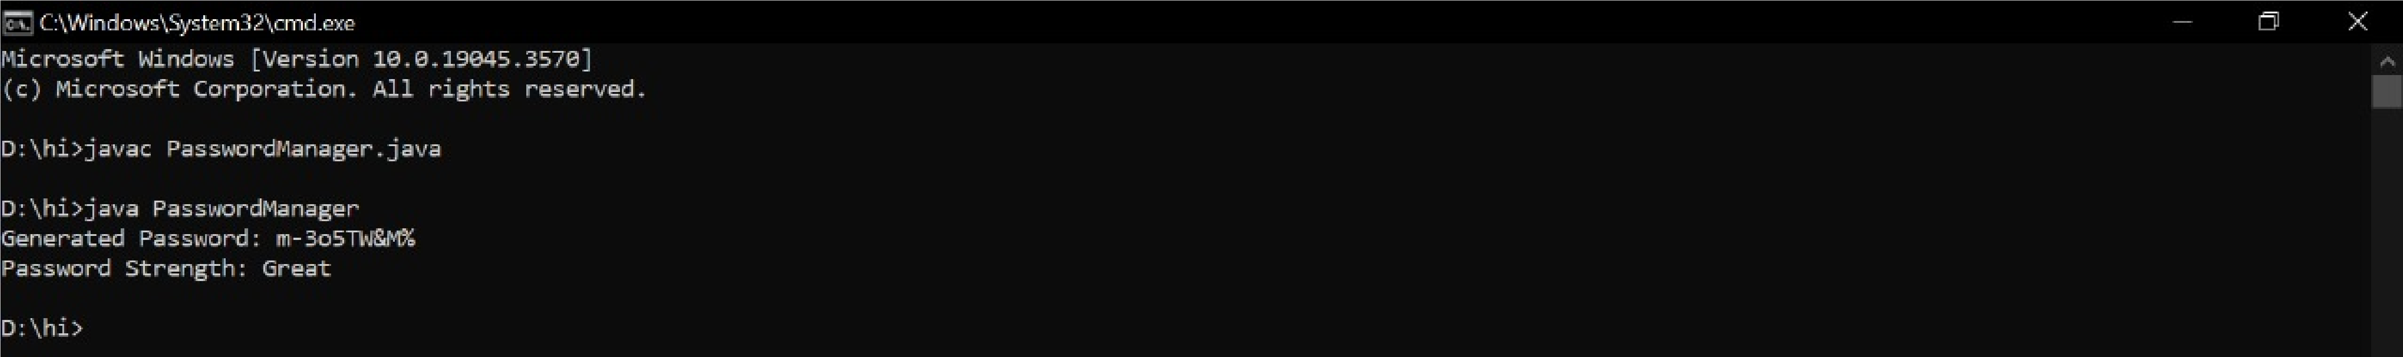

RESULTS AND ACHIEVEMENTS

Successfully implemented Java-based mini project.Upon successful completion of the

Password Generator Java project, we have achieved the following:

Secure Password Generation: The project successfully generates secure and unique passwords, enhancing the security of users’ digital identities.



Efficient Performance: The Password Generator operates efficiently, generating passwords quickly and without errors.

Future Scope: The successful completion of this project opens up possibilities for future enhancements, such as integrating the Password Generator with other applications or developing a mobile app version.

# CONCLUSION

This Password Generator project has provided us with valuable insights and practical knowledge on various topics such as

Java, secure coding practices, and the importance of strong password policies. The system is designed with security as a

priority.We learned how to test different features of a project

and ensure they meet the expected outcomes. The successful completion of this project within the stipulated time, and its

performance exceeding our expectations, stands testament to the effectiveness of our learning and application. This experience will undoubtedly be beneficial in our future endeavors in software development.



Thank you for giving uthe opportunity to showcase our Java skills!

